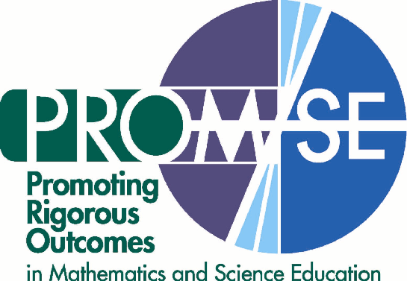
PROM/SE Science Associates Fall 2005 Workshop
October 17-18, SMART, Cleveland, OH
October 19-20, High AIMS, Cincinnati, OH
October 24-25, Calhoun ISD, Ingham ISD,
St. Clair RESA, East Lansing. MI

Facilitators: Doug Estry, MSU; Nancy Landes, BSCS; Sam Spiegel, BSCS; Deb Jordan , BSCS;
Rhonda Graham, Oliver High School; Geoffrey Martin, Pershing Middle School; John Rowe, Clark Montessori Junior HS; Jill Brownlee, Madison High School

Goals:
- To help PROM/SE Science Associates think about important concepts in science and how to organize instruction to promote conceptual understanding of those concepts
- To deepen PROM/SE Science Associates’ understanding of a specific scientific concept and common misconceptions related to that concept: Earth and Earth’s moon are in regular and predictable motion in the solar system. Those motions in relation to the position of the sun explain such phenomena as phases of the moon and eclipses.
- To associate the concept of models in science with understanding the sun, Earth, moon system
- To relate the research on learning, specifically the three key findings from How People Learn (HPL), to understanding a specific “big idea” in science
- To connect the HPL research findings to Analyzing Instructional Materials (AIM) for learning important science concepts

Day 1
3:30 p.m. Registration
Reception/Dinner (time varies by site)

4:00 p.m. Welcome and Introductions
Quiz: Sun, Earth, Moon System
Exploration of Sun, Earth, Moon System
Standards and Learning
Wrap up, Reflection, and Overview of Day 2

8:00 Adjourn

Day 2
7:30 Registration

8:00 Welcome Back with a Quickwrite
Exploration of Sun, Earth, Moon System Revisited
Break
Sun, Moon, Earth Jigsaw

11:30 Lunch

12:15 Explanatory Model of Sun, Earth, Moon System
Gallery Walk of Models
Break
Post-Quiz (What have you learned?)
Classroom Application
Wrap up and Reflection

4:00 Adjourn

