March 31, 2006

Dear PROM/SE Associate,

As an acknowledgement of the critical role and contributions of PROM/SE Associates, a special invitation is being extended to all Associates to participate in one of the three Special Courses that are being offered on an academic credit basis for this summer. While all PROM/SE teachers can apply for any one of the courses, PROM/SE Associates will receive preference and are encouraged to register early. After May 1, 2006 any openings will be made available to other PROM/SE educators who apply.

SPECIAL COURSES (see flyer for details)
- Dr. Hung-Hsi Wu, Mathematics Professor, University of California at Berkeley “Advanced Study of Whole Numbers and Fundamental Concept of Number”
2 credits, Teachers of Grades K-4
July 31 - Aug. 4, 2006, 8:00 am - 3:30 pm, Cleveland, OH (Note: This is a 5-day course.)

- Dr. Paul Sally, Professor of Mathematics, University of Chicago
“Algebra for Middle School Teachers with Connections”
2 credits, Teachers of Grades 6-8
Aug. 14 - 18, 2006, 8:00 am - 3:30 pm, Holt, MI (Note: This is a 5-day course.)

- Dr. Glenda Lappan, University Distinguished Professor, Michigan State University “Rational Numbers and Proportional Reasoning”
3 credits, Teachers of Grades K-8
July 5 - 21, 2006, 8:00 am - 11:15 am, East Lansing, MI (limited enrollment available)

The Special Courses must be taken for credit through Michigan State University and will require substantial work beyond the regular PROM/SE Summer Mathematics Academy offerings. Participation in these courses will require deep thinking about fundamental concepts and will include homework. Individuals who truly want to expand their understanding of mathematical concepts are highly encouraged to attend; these are unique opportunities for studying with key leaders in the field.

Participants who take one of the Special Courses will be eligible to receive a higher than usual stipend to cover the additional work of the courses: $60 per day for Dr. Lappan’s 13-day course and $132 per day for the 5-day courses of Drs. Wu and Sally. Additionally, participants who travel more than 50 miles will be eligible to be reimbursed up to $425 for Dr. Wu’s and Dr. Sally’s course, and up to $1,000 for room (receipt required), meals, and travel expenses for Dr. Lappan’s course. (PROM/SE will assist in locating inexpensive local housing options.)

You will need to complete a MSU application to enroll in Dr. Wu’s or Dr. Sally’s course. Becky Murthum (murthum@msu.edu) will mail the application upon receipt of your PROM/SE Summer Mathematics Registration Form. If you are interested in taking Dr. Lappan’s course, please download the application form from http://www.dsme.msu.edu and submit it to the address indicated on the form by May 1, 2006. Be sure to indicate that you are interested in receiving Towsley tuition support and that you are a PROM/SE Associate at the top of the form, next to your name.

We are delighted to be able to extend this opportunity to you. Space is limited, so please apply today.

Sincerely,

Joan Ferrini-Mundy,
Co-Principal Investigator

SUMMER 2006
SPECIAL COURSE OFFERINGS
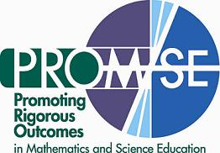

PROM/SE is pleased to announce that nationally recognized mathematicians and mathematics educators
will teach three academic courses as part of our summer program. These courses are open to all PROM/SE Associates and teachers from any of the five partner sites in Michigan and Ohio. Note that each of these three courses is being given for credit through Michigan State University. Non-credit participation is not available.
Credit arrangements can be made through Becky Murthum (murthum@msu.edu).

Advanced Study of Whole Numbers and Fundamental Concept of Number
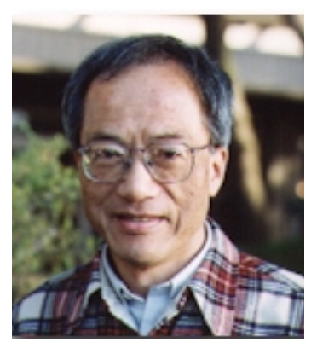
2 credits

Instructor: Dr. Hung-Hsi Wu, Professor of Mathematics, University of California at Berkeley

Course description: This course will focus on developing the reasoning underlying the concept of a number, the standard algorithms, estimation, and place value of the decimal numeral system. Working in small groups, lectures, and daily homework assignments are an integral part of this course.

Dr. Wu is an internationally recognized expert in mathematics education and an outstanding teacher. This course will be offered July 31 – August 4, 2006 as part of the SMART Summer Mathematics Academy in Cleveland, Ohio. (Please note that this is a 5-day course.) This course is targeted for K–4 teachers; however it is appropriate for all K-6 teachers. Submit a PROM/SE Summer Mathematics Academy Registration Form to reserve a spot in this course.

Algebra for Middle School Teachers with Connections
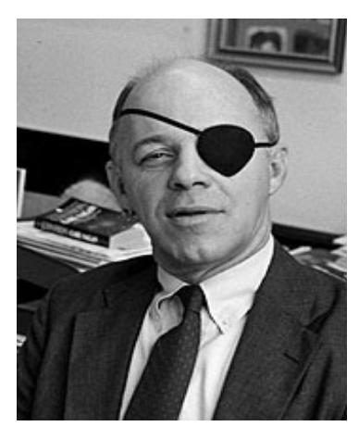
2 credits
Instructor: Dr. Paul Sally, Professor of Mathematics, University of Chicago

Course description: This course will treat linear equations in one and two variables with applications to problem solving. Next, we discuss quadratic equations in two variables, especially circles and parabolas. We will also cover linear and quadratic inequalities with applications. Word problems, from simple to difficult, will appear everywhere.

Dr. Sally was the first director of the University of Chicago School Mathematics Project and has received several distinguished service awards. This course will be offered for teachers of grades 6-8, August 14 – 18, 2006, as part of the Michigan Summer Mathematics Academy in Holt, Michigan. (Please note that this is a 5-day course.) Submit a PROM/SE Summer Mathematics Academy Registration Form to reserve a spot in this course.

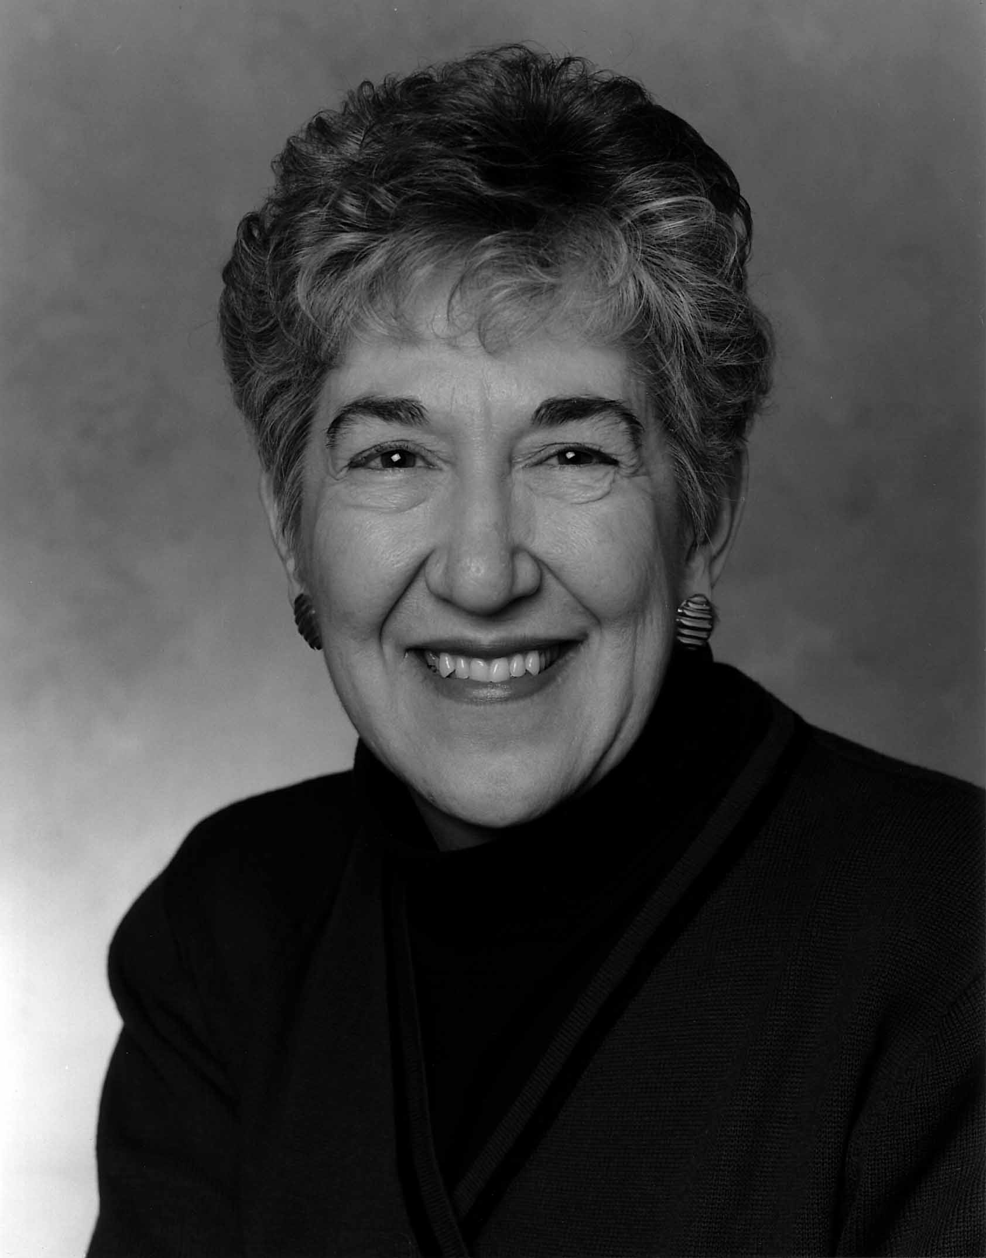
SME600~3 credits
Rational Numbers and Proportional Reasoning
3 credits
Instructor: Dr. Glenda Lappan, University Distinguished Professor, Michigan State University

Course description: This course will focus on developing proportional reasoning, equivalence and models for rational numbers, conceptual underpinnings of algorithms, extensions to the real number system and linear functions, and properties of real numbers.

Dr. Lappan is an internationally recognized expert in mathematics education and co-director of the Connected Mathematics Project. This course will be offered July 5 – July 21, 2006, weekday mornings 8 – 11:15 am, at Michigan State University. This course is targeted for K – 8 teachers. Participants must enroll for MSU graduate credit and complete the MSU application process to enroll in this course. Download and complete an application form from http://www.dsme.edu; follow the links for >>Math Ed>> Summer courses for Middle School Mathematics Teachers>>.

____________________________________________________________________________________________________________________
PROM/SE is supported by the National Science Foundation under cooperative agreement EHR-0314866

