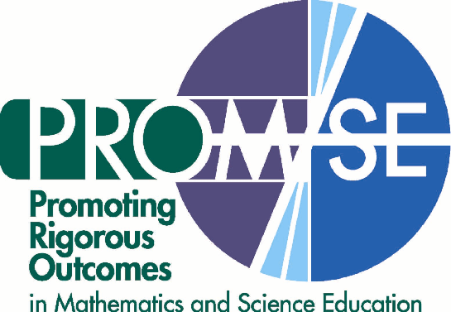

October 17-25, 2005

Dear PROM/SE Science Associate:

Welcome to the 2005 PROM/SE Science Associates Fall Professional Development! We are pleased to have this opportunity to work with you, and appreciate your willingness to spend this time with us. We are delighted to have established such wonderfully collaborative relationships with our Ohio partners (SMART and High AIMS) and our Michigan partners (Calhoun ISD, Ingham ISD, and St. Clair County RESA). The success of this project will ultimately depend upon how effectively all of us can work together. We hope that you as an Associate find this to be a productive relationship that benefits you and your students both now and well into the future.

We invite you to think about these days as the next steps of an important professional and intellectual journey that was started last spring. Our destination is a land in which all students learn the scientific skills and concepts they need to live and succeed in our increasingly complex and technological world. It is a destination we can imagine – even if we have to admit that we don’t know exactly how to get there yet.

Our PROM/SE partnership is founded in part on the premise that the best way to reach the destination of science literacy for all students is to have a map based on very precise data (much better data than is typically available) about what students know and what they need more help with, what teachers feel comfortable teaching and what they need more help with, and what the instructional materials cover and what those materials need to cover. These data will allow us to identify, design, and provide truly innovative, effective professional development, tailored specifically to your needs and circumstances as well as those of your students.

During this fall professional development event, you will deepen your content knowledge of specific science concepts related to learning about the sun, earth, and moon system. This is one of many PROM/SE professional development events being planned for the next three years. As Science Associates, you truly represent the cutting edge of this exciting endeavor. We look forward to meeting and hearing from you. You represent the best chance for science success for all students – the promise of PROM/SE – and we thank you for your commitment to the students’ well being.

Sincerely,

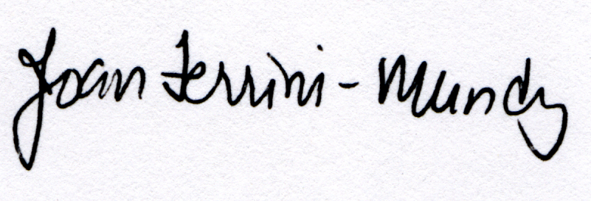
Joan Ferrini-Mundy Bill Schmidt
PROM/SE Principal Investigator PROM/SE Co-Principal Investigator

