PROM/SE  Promoting Rigorous Outcomes in Mathematics and Science Education  Funded by:  The National Science Foundation  under Cooperative Agreement  Grant No. EHR-0314866  PROM/SE Partners:  SMART Consortium  22800 Cedar Point Road  Cleveland, OH 44142  Telephone: 440-962-3000  www.oai.org  The HIGH AIMS Consortium  6100 S. Mason Montgomery Road  Mason, OH 45040  Telephone: 513-229-4060  www.highaims.org  INGHAM Intermediate  School District  2630 West Howell Road  Thorburn Education Center  Mason, MI 48854  Telephone: 517-676-1051  www.inghamisd.org  CALHOUN Intermediate School District  17111 G Drive North  Marshall, MI 49068  Telephone: 269-789-2452  http://calhounisd.org  ST. CLAIR Intermediate School District  499 Range Rd. / P.O. Box 1500, Marysville, MI 48040  Telephone: 810-364-8990  www.sccresa.org  Michigan State University  230 Erickson Hall  East Lansing, MI 48824  Telephone: 517-353-7755  www.promse.msu.edu | March 2, 2005  Dear District Curriculum Contact:  The PROM/SE leadership team at Michigan State University (MSU) invites you to a Curriculum Directors’ Summit. The purpose of the Summit is to clarify needs and roles of PROM/SE participants, and find ways to work together in support of local efforts within the PROM/SE school districts to improve mathematics and science teaching and learning, especially through capacity building with teacher professional development. We deeply regret the short notice, but assure you that this capstone meeting is in response to emerging needs, and will be pivotal in helping to create a roadmap for our work together. If you personally are unable to attend this first meeting of local school district representatives, then please send an alternate district-level administrator to represent your schools.  The Summit will be:  Date: March 15, 2005  Time: 9:30 a.m.-3:30 p.m.  Venue: Olscamp Hall  Bowling Green State University  Bowling Green, Ohio  The site of the PROM/SE Curriculum Director's Summit has easy access to I-75, for both Michigan and Ohio participants.  This conference is scheduled in response to a number of requests that we have had from our partners, as well as directly from districts represented in PROM/SE, as a means of creating a stronger community of leaders engaged in the improvement of mathematics and science teaching in the PROM/SE districts. A steering committee composed of representatives from the six PROM/SE partners has recognized the critical role of curriculum directors and other district administrators within the local districts, and seeks your expertise. With this in mind, the goals of the meeting are to:  • focus on how PROM/SE can be a useful resource in the work of each district and  • consider how PROM/SE district contacts and Associates can help expand the capacity of districts to make improvements in mathematics and science education.  We will focus particularly on how PROM/SE and the work of the PROM/SE associates and curriculum directors can be integrated with the work of the district central office, as well as concerns with professional
development for mathematics and science knowledge, education, and leadership. With your assistance and participation, we hope to answer questions about PROM/SE, and clarify the critical role of district curriculum directors and associates. Together, we hope to create a truly unique and effective approach for improving mathematics and science education within participating districts.

Enclosed is a map with directions to the meeting site and parking instructions, along with hotel information, a PROM/SE reimbursement form, and a short brochure about PROM/SE. We expect to have both large and small group activities at this Summit so that we can better address your concerns. As always, the steering committee welcomes your suggestions prior to finalizing the agenda.

To help us better plan for this event, please RSVP as soon as possible (hopefully by March 8) to Dr. Nancy Nelson Knupfer, PROM/SE Director of Professional Development, at nknupfer@msu.edu. In your e-mail RSVP, it would be helpful if you note any specific questions that you would like addressed at this Summit, relative to the role of PROM/SE, district administrators, curriculum directors, and teaching associates for working together. If you will need a hotel room for the night before the Summit (if driving more than 90 miles), please book your room directly with one of the two hotels listed on the enclosed information sheet. We recommend booking promptly for best availability,

We look forward to receiving your response and seeing you in Bowling Green to build our joint vision for working together to improve mathematics and science education. As always, we thank you for your input and support.

Sincerely yours,
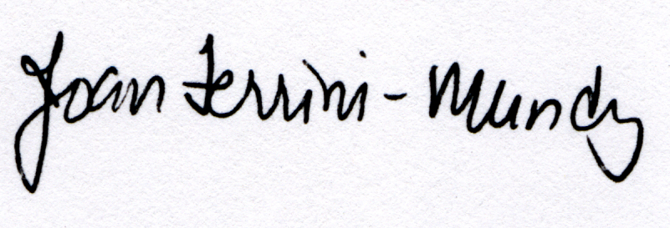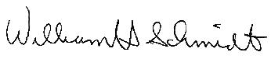
Joan Ferrini-Mundy William Schmidt
PROM/SE Principal Investigator PROM/SE Principal Investigator

Enclosures: Draft Agenda
Map with directions to the meeting site and parking information
Hotel information
PROM/SE reimbursement form

Addendum -- Thanks to the steering committee members for their efforts in planning this event:
- MSU Joan Ferrini-Mundy (Chair), Mary Bouck, Gail Burrill,
Nancy Nelson Knupfer, and Bruce Umpstead
- SMART Nancy Burce, Anna Maria Tabernik, Elizabeth Taylor, George Viebranz, and Terry Krivak
- High AIMS Rick Bateman, Kevin Stinson, Bob Yearout, Terry Joyner, and Kimya Moyo
- Ingham Marty Couretas
- Calhoun Mary Gehrig
- St. Clair Terry Parks

